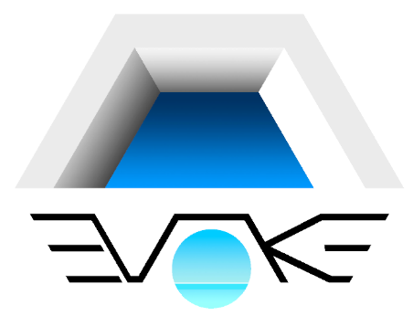

**Specifications**

**Construction**  
**Included:**  
House  
Pool + pool filtering equipment (underground)  
Exterior terraces (pavement)  and car entrance pavement  
Perimeter walls and/or fences  
Windows: aluminum with thermal bridge break, white lacquered colour in ibiza style houses, anthracite grey in modern houses.  
Automatic blind on windows (not in units wider than 3m and bathroom units)  
Built-in wardrobes (entrance and bedrooms)  
Kitchen furniture and countertop (silestone or similar)  
Kitchen appliances included: oven, cooktop, hood extractor, sink  
Wooden beams in living room.  
Bathroom: all large items included: tiling, appliances, shower tray, shower screen, mirror, etc  
Floortiles: porcelanic tiles 30x60 size or similar. Other sizes available. Other types of floor available (parquet, stamped concrete, etc).  
Water heater: Solar panel in rooftop, secondary electrical heater for backup  
Underfloor heating in bathrooms (electrical)  
Air Conditioning: Built-in installation (ducts embedded in the ceiling, and piping), global temperature control (overall T in all rooms)  
Door intercom with camera  
Automatic gates for car entrances or garage.  
Light appliances: both interior and exterior.  
Perimeter walls: Façade/street walls, according to local regulations, White coated + transparent element (metallic plate with holes, or lattice blocks).   
Other walls: 1m solid wall, coated + 1m wirefence.  
  
  
**Not included:**  
House appliances: microwave, dishwasher, fridge, washing machine or drier not included (installations are included).  
Furniture.  
Landscape project: irrigation, color gravel (white and dark volcanic, plants and automatic irrigation, shading material on perimeter wall wirefence (bamboo sticks or other)  
(included finish for exterior ground areas is a conventional gravel, same type used for concrete).

**OTHER ITEMS:**  
We deliver key-in-hand projects and take care of most paperwork required.  
  
**Included:**  
Architect fees  
Building license on city hall  
Aparejador fees (building engineer or manager)  
Structural calculations  
Technical control (concrete and steel samples, etc)  
Ten year insurance for structure of the house (Seguro decenal)  
Ground study (drilling tests or geotechnical study)  
Certifications: energetical (thermal insulation), acoustic, roof waterproofing test.  
  
**Not included:**  
Property titles or lawyer’s fees.  
Fees from service provider companies (water, electricity, sewers, garbage collection, etc.)

**Taxation:** our prices advertised on the webpages don´t include VAT or taxes.  
Normally is 10% (instead of 21%) when client firstly buys the plot and the becomes the "promotor" and hire us as a building company.   
  
**Building contract:**

Contract for both buying the plot and hiring the construction, is done or signed the same day at the same time.  
  
Consult us for other options.  
  
**Payment schedule**  
Out standard procedure for new projects (obra nueva). Is the following:  
  
**1_** **Signing of building contract and purchase of plot.**  
Payment of 100% of the plot + 10% of the construction  
(30% of sales commission is paid at this stage)  
Payment used for preliminary tasks (architect project, building license, ground study, 10 years structure insurance, certifications, etc).  
  
**2_** **Building license is granted.**  
Payment of 35% of the construction  
(remaining 70% of sales commission is paid at this stage)  
Construction officially begins  
  
**3_** **Monthly payments**Payments are done monthly according to actual building progress, certifications signed by architect (dirección facultativa).  
5% of payments is retained by client.  
  
**4_** **Construction finished**When construction is finished, the last payment which is the total 5% retained from previous payments, will be paid. In one of two conditions: when cedula de primera ocupación is granted by city hall (after passing city hall inspection), or if the clients decides he want to start living in the house.  
Keys will be delivered then.

From that moment, electric and water service bills will be transferred to clients accounts.

**Customization:**  
  
It´s possible to customize different items.  
  
A full specification dossier, with images and data sheets is provided.  
Prior to building of the house, visitations to suppliers showrooms can be done to see samples of tiles, kitchen furniture and countertop, doors and wardrobes.

Different colors and models to choose from.